ASSESSMENT - 13 | PYTHON - 06

*“PYTHON OOPS, FILE HANDLING, & EXCEPTION HANDLING, MODULE”*



Submitted By

VAIBHAV PATIDAR

IPS ACADEMY, INDORE (M.P.)

**Date :** 18-12-2023 | **Day 13**

**Week 3** | **Day - 01**

**→ Object Oriented Programming [OOPS] in Python :**

* In this type of programming , Objects and Classes are used to create more efficient and reusable code.
* OOPS is used to implement some concepts like :
  + Class
  + Objects
  + Polymorphism
  + Encapsulation
  + Inheritance

**→ Class & Object in OOPs :**

1. **Classes :**

Classes are like a blueprint that contains the basic structure or template that cna be used for multiple objects.

1. **Objects :**

To use the code or blueprint written in the CLASS , we create object, each object can use the class properties with unique values.

**Writing a program to explain the CLASS & OBJECT principle :**

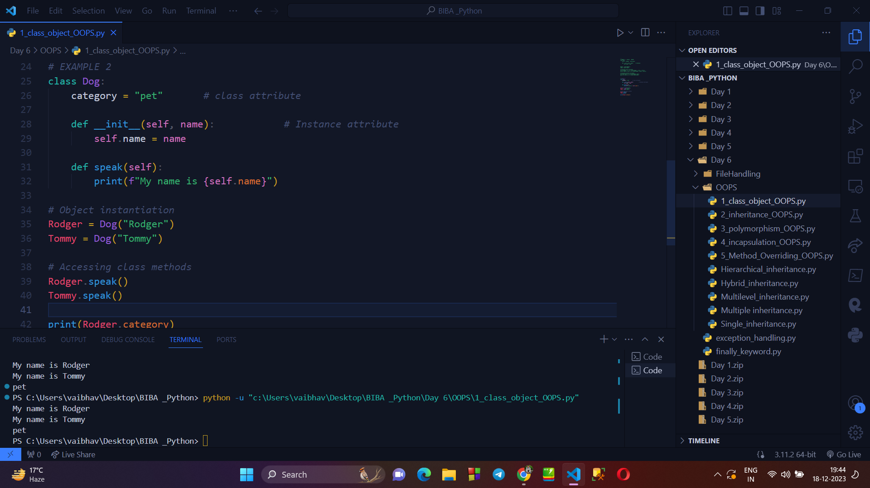

**→ INHERITANCE IN OOPS :**

* Inheritance is a property in which one class can inherit the properties of another class.
* The class which inherits the properties is called the derived or child class and the class whose properties are inherited is called base class or parent class.

**Writing a program to explain INHERITANCE :**

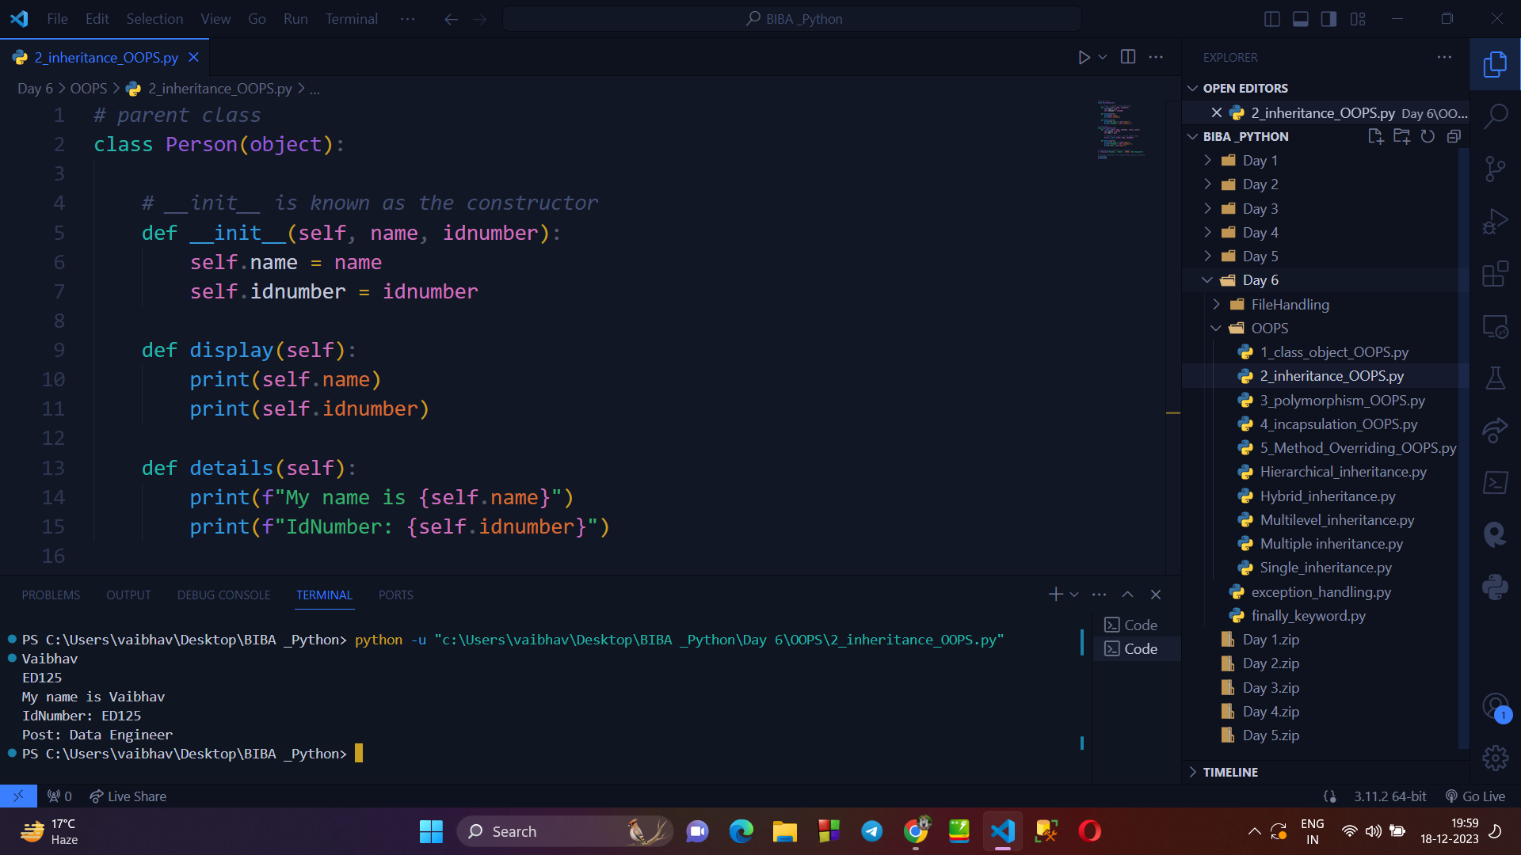

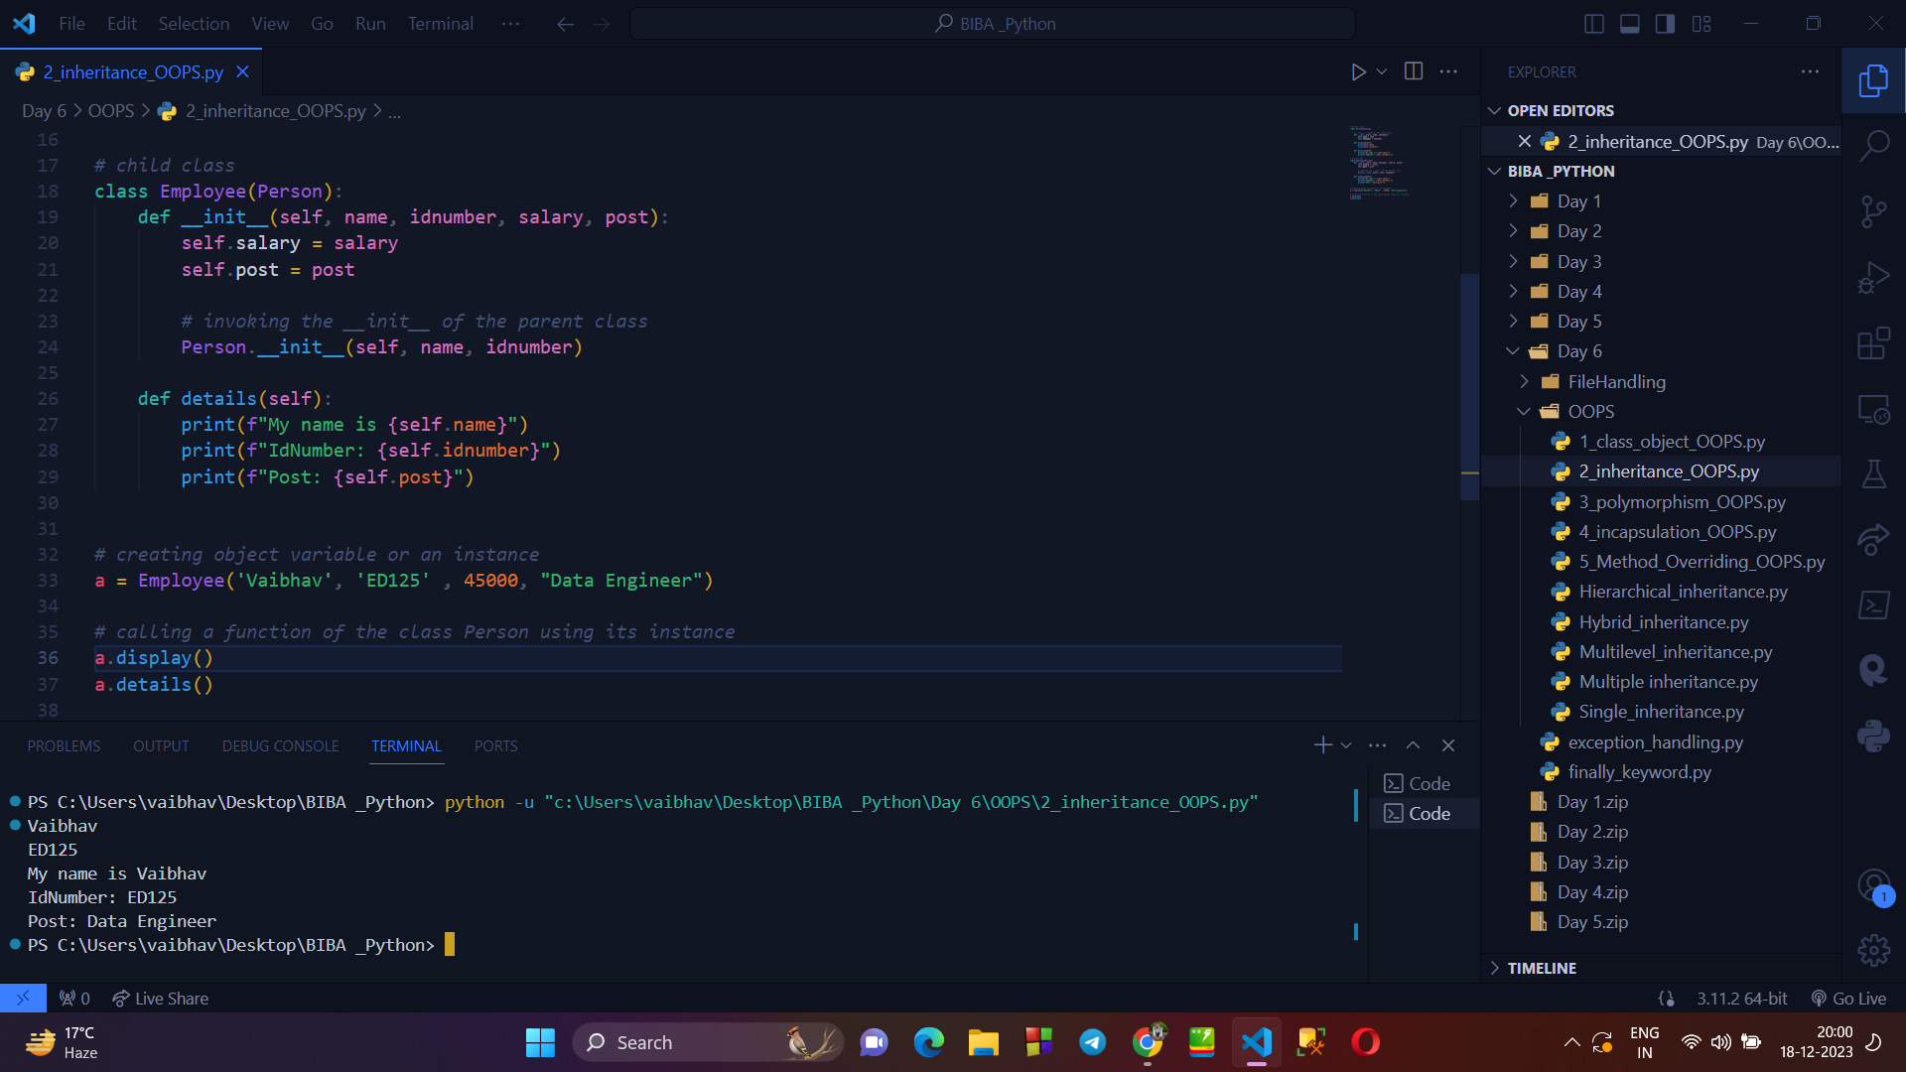

**→ POLYMORPHISM IN OOPS :**

* Polymorphism , one class can be used in different forms.
* Means, on class can inherit the properties of other class and can also use some additional properties written within it.

**Writing a programm to explain POLYMORPHISM :**

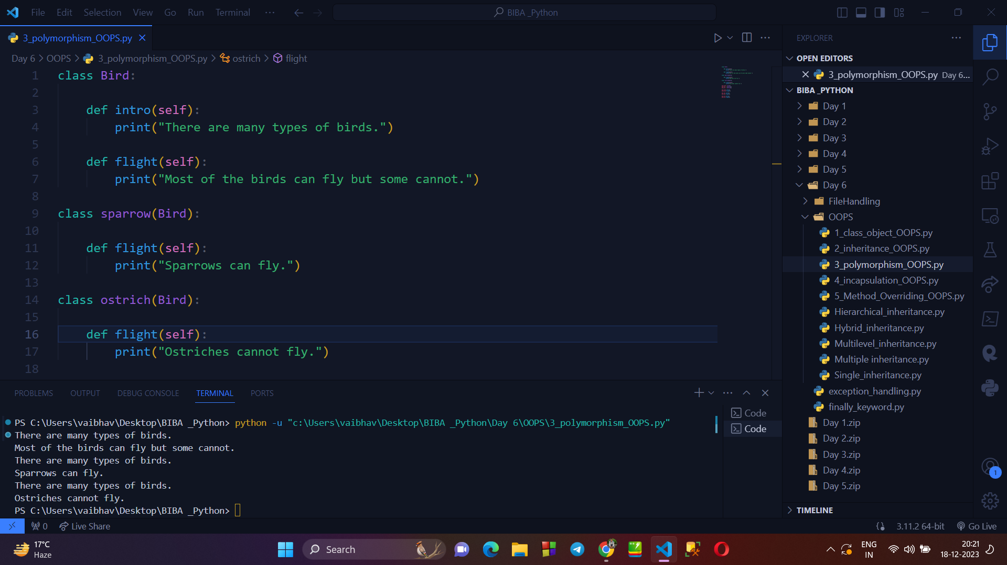

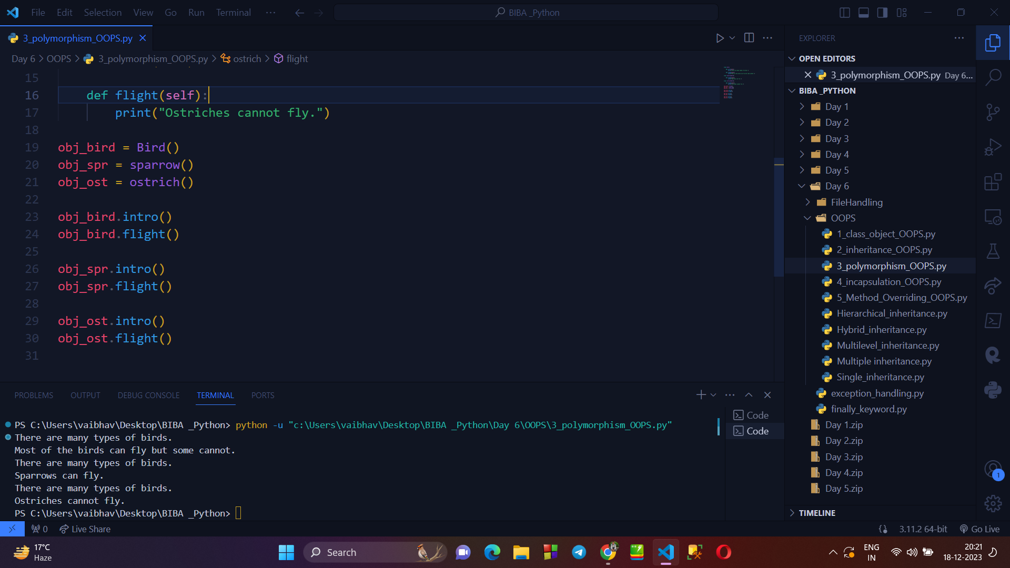

**→ ENCAPSULATION IN OOPS :**

* The process of wrapping data and the methods working on that data in a capsule is called encapsulation.
* Encapsulation prevents the unauthorized access to variables and methods.

**Writing a program to explain ENCAPSULATION :**

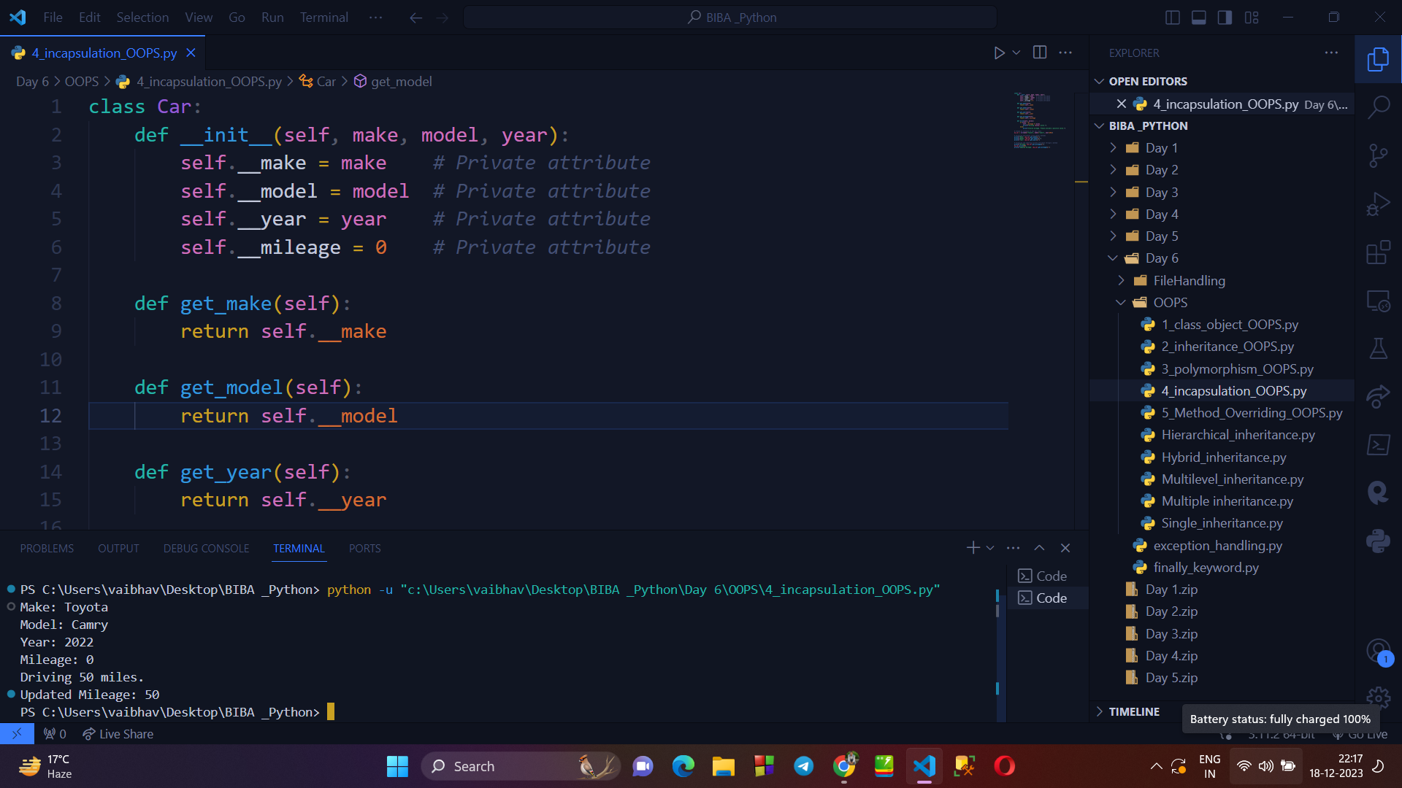

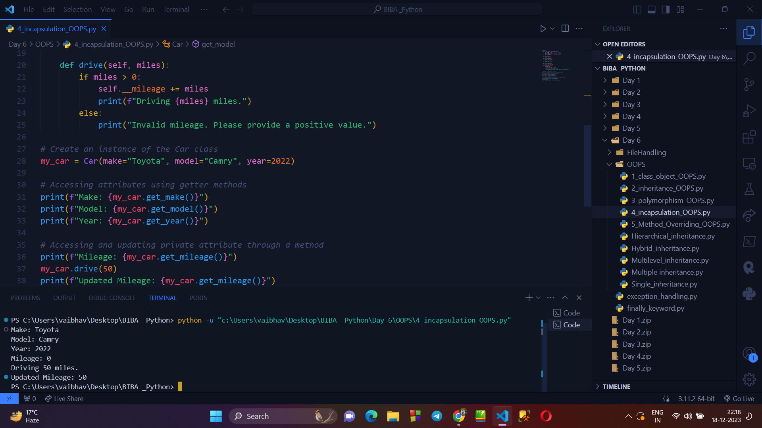

**→ METHOD OVERRIDING IN PYTHON, EXAMPLE :**

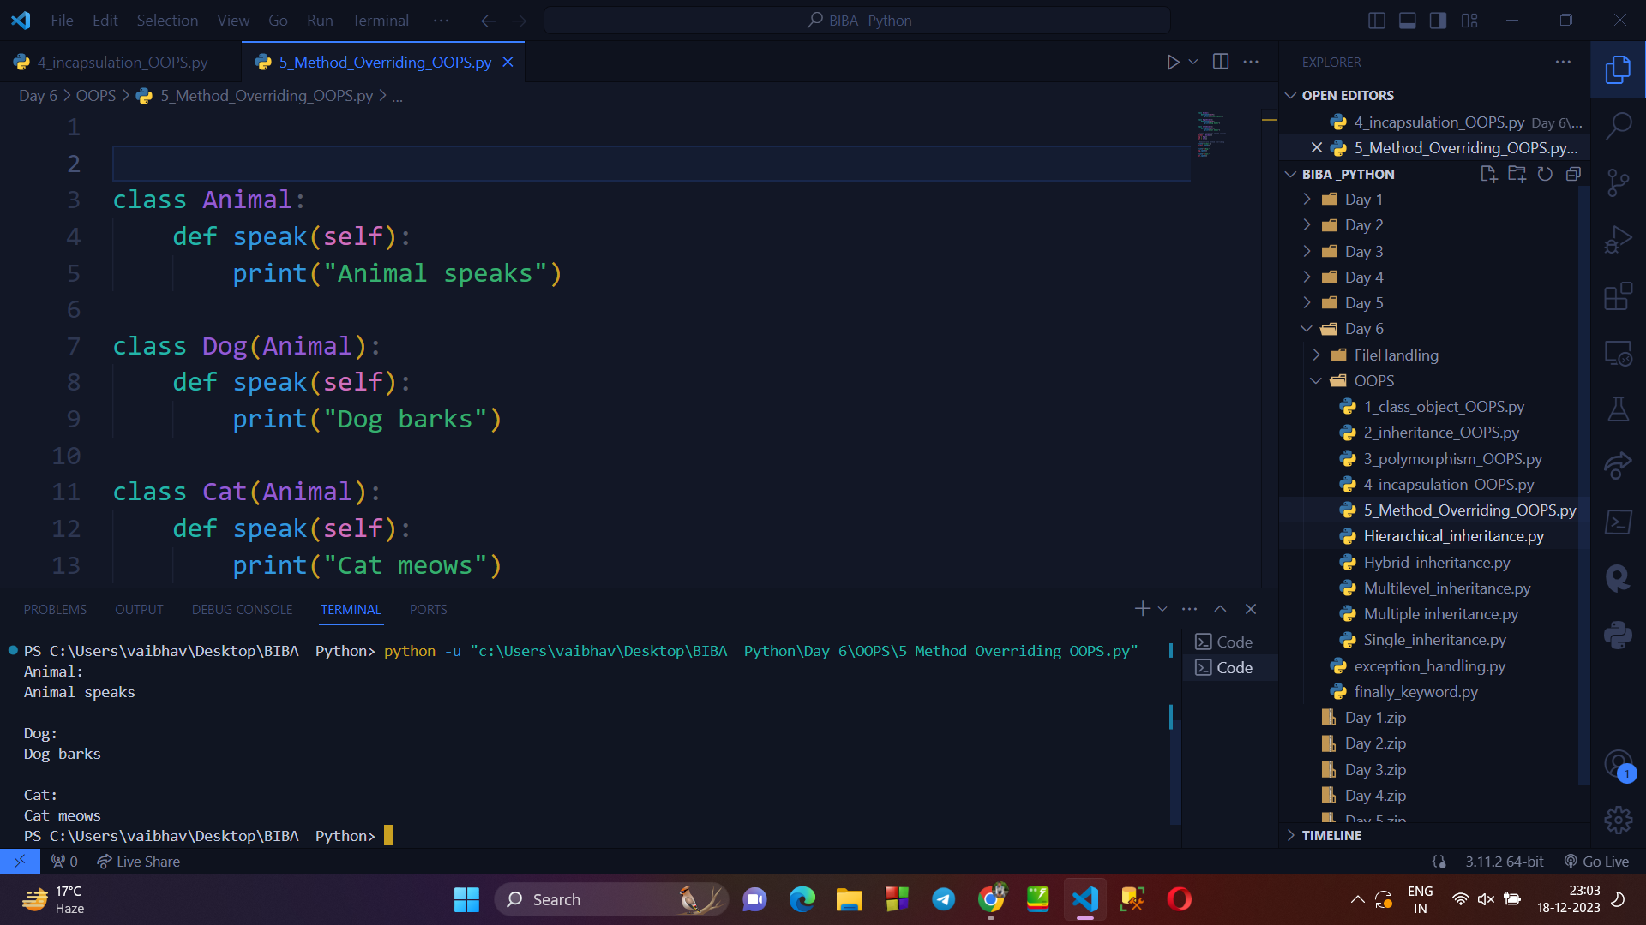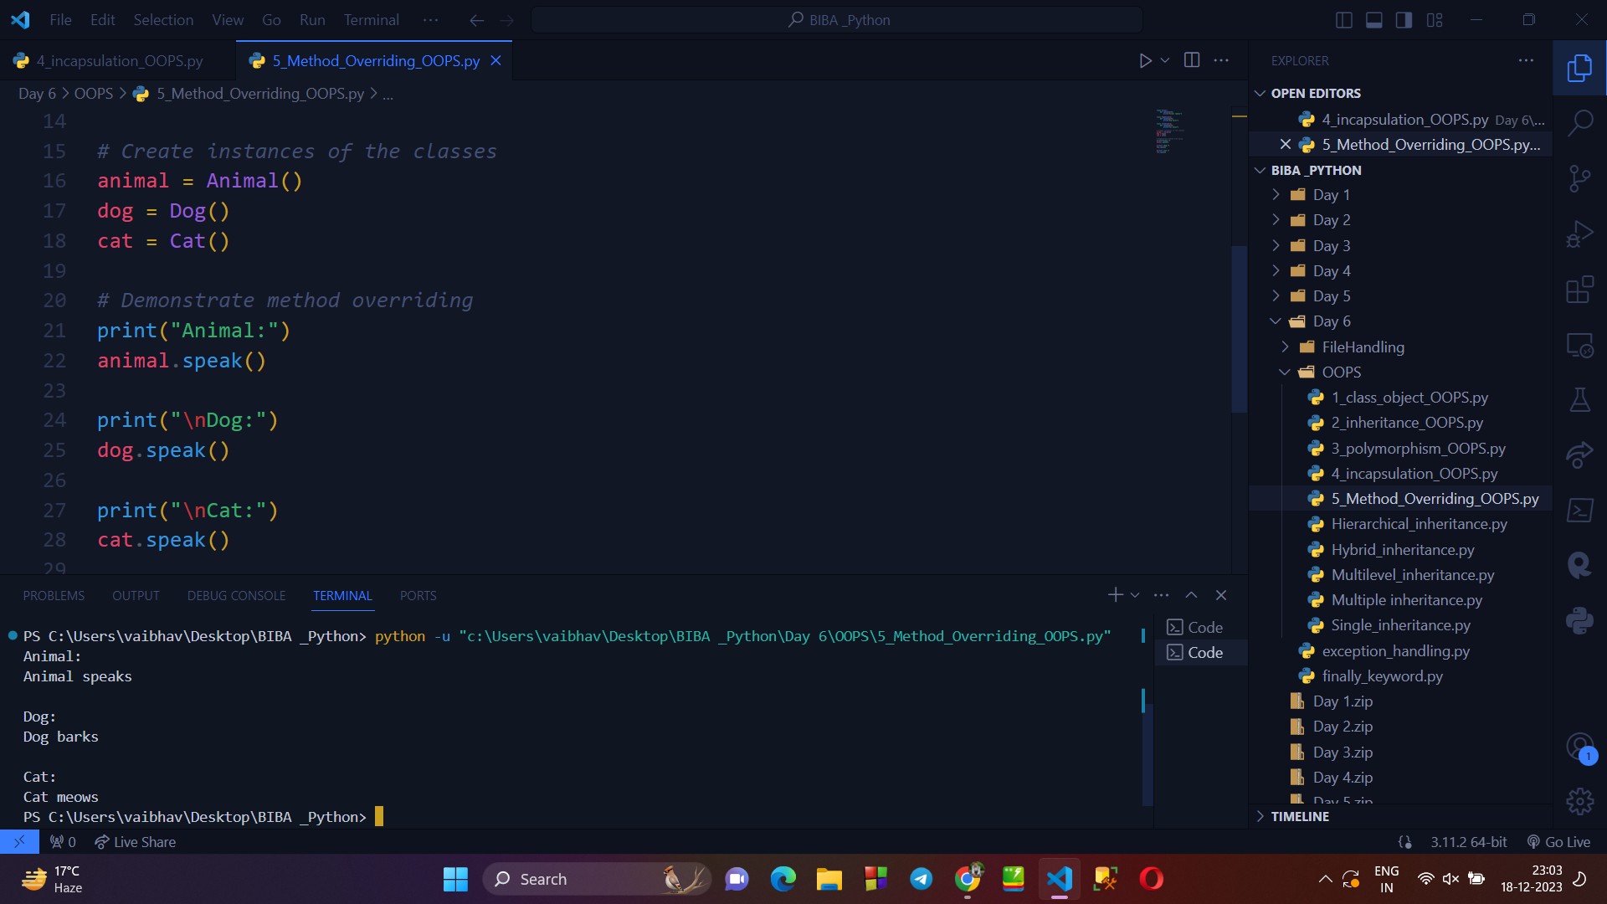

**→ TYPES OF INHERITANCE :**

1. Single inheritance : In single inheritance you can derive a (child) class from a single parent class Example :

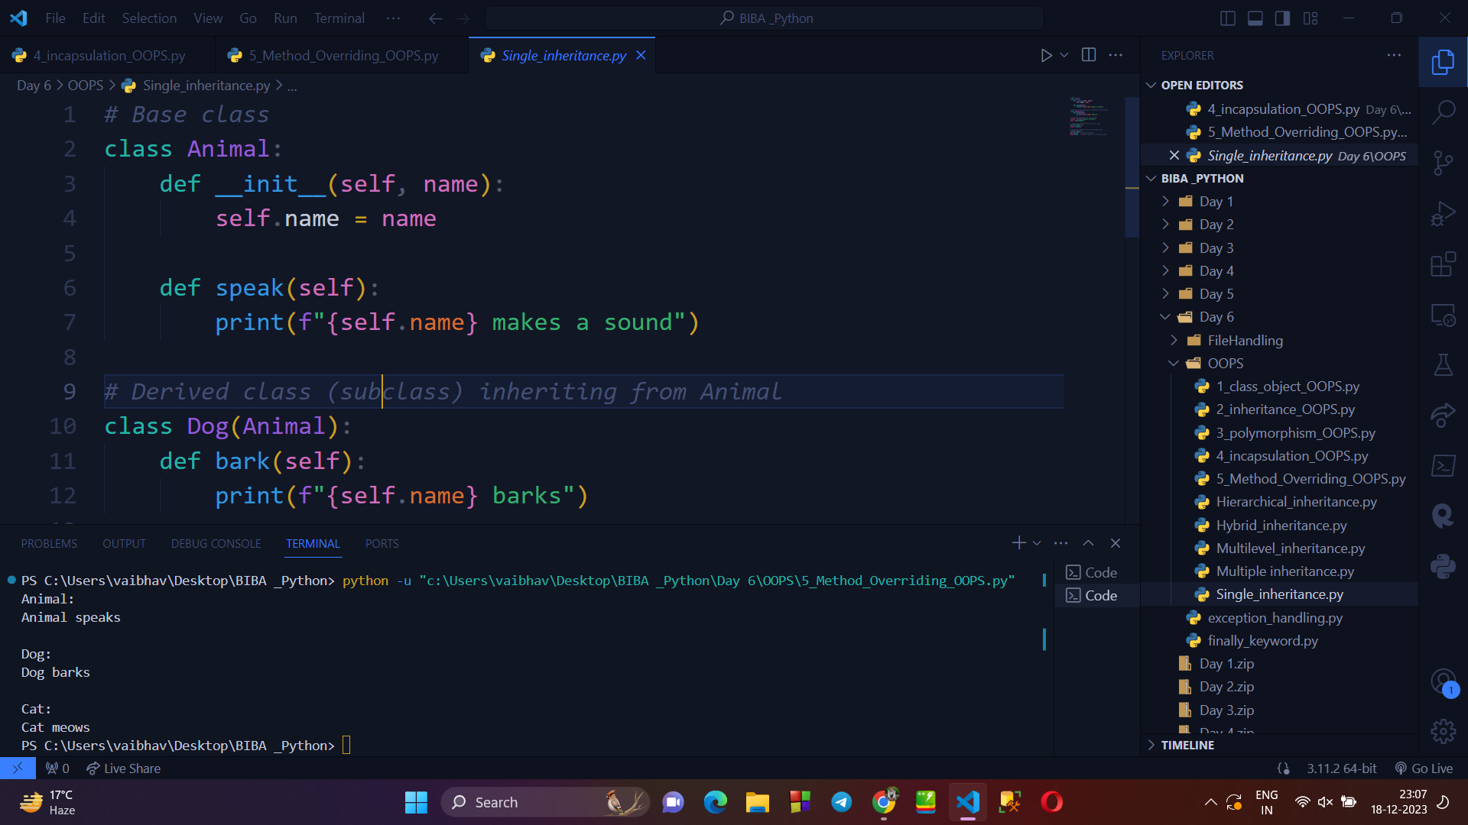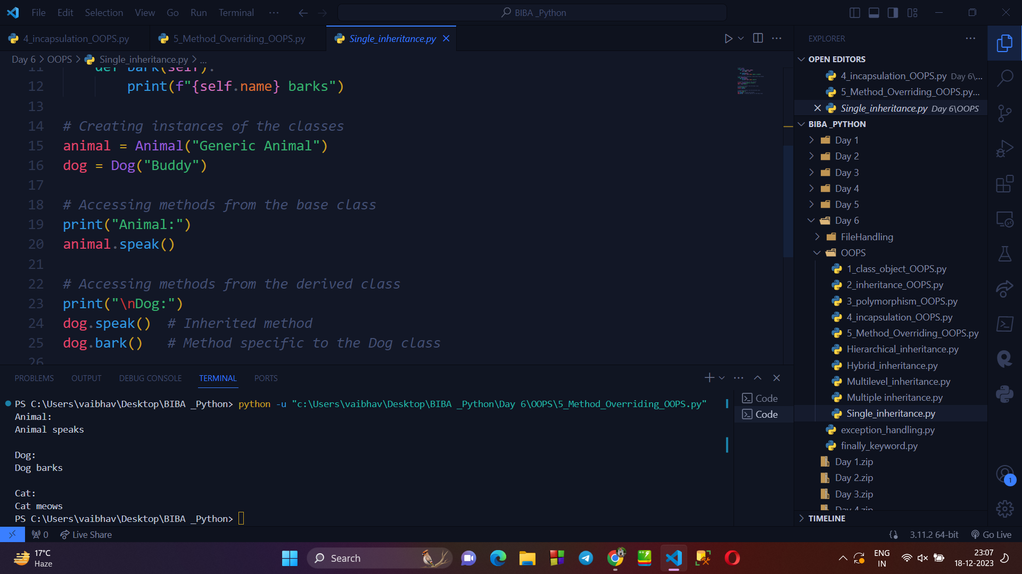

1. Multilevel Inertance : In multilevel heritance a new derived class inherits the properties of the base class. Example :

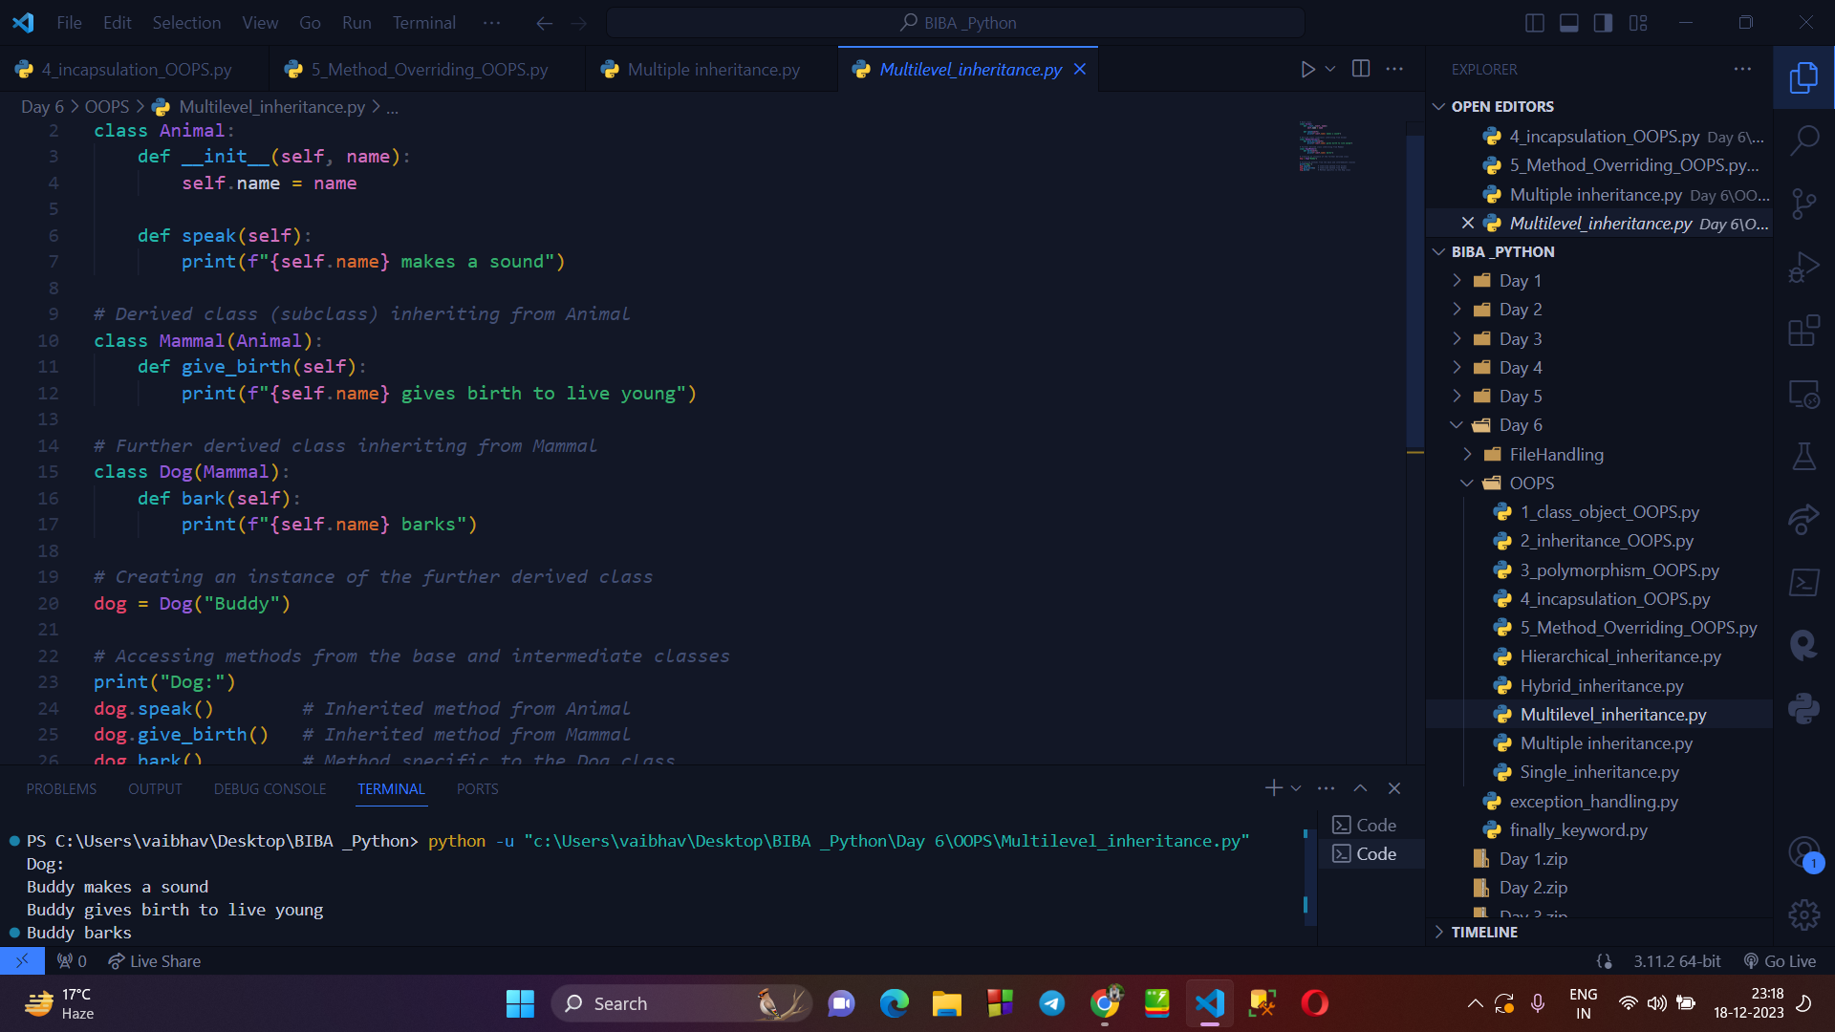

1. Multiple Assests : In it you can inherit the features of more classes into a single class.

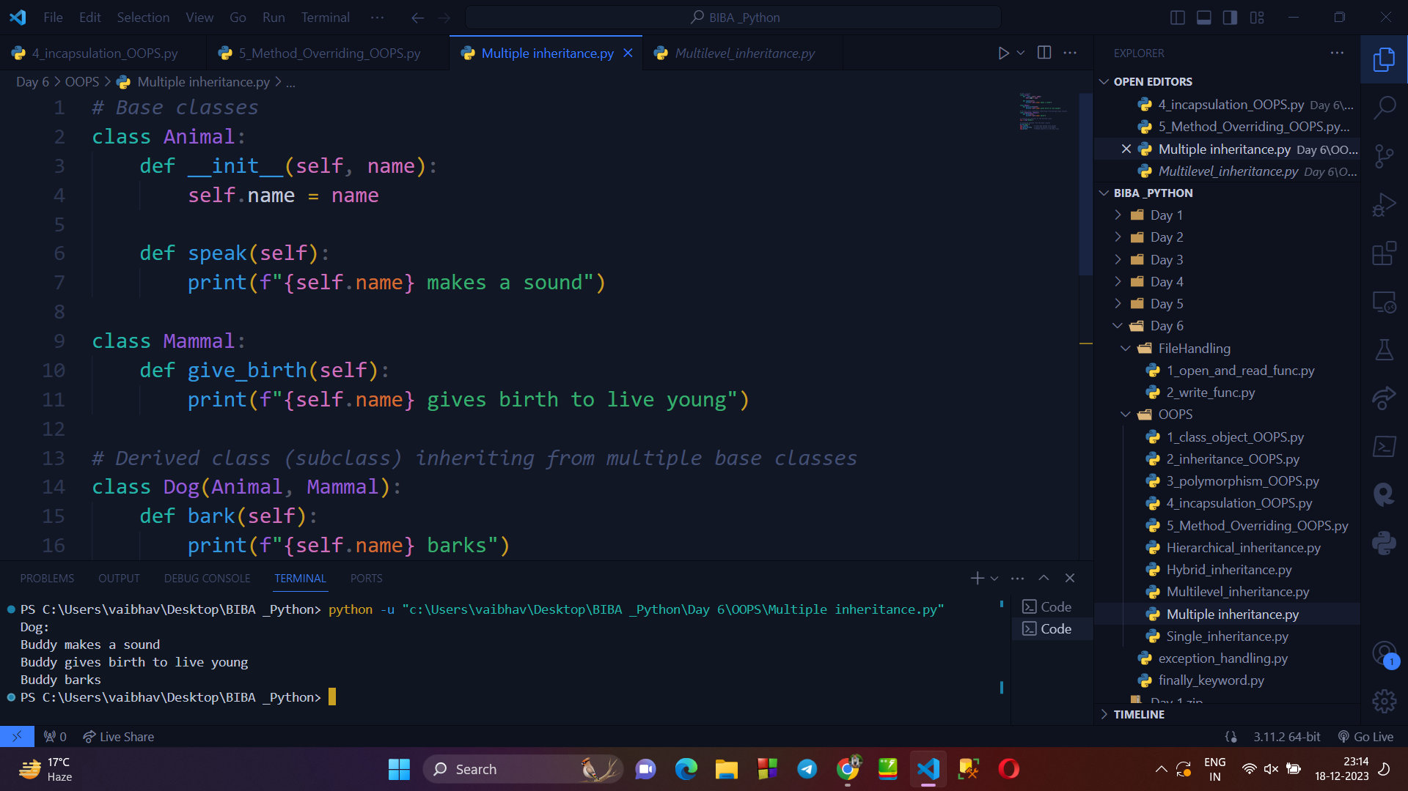

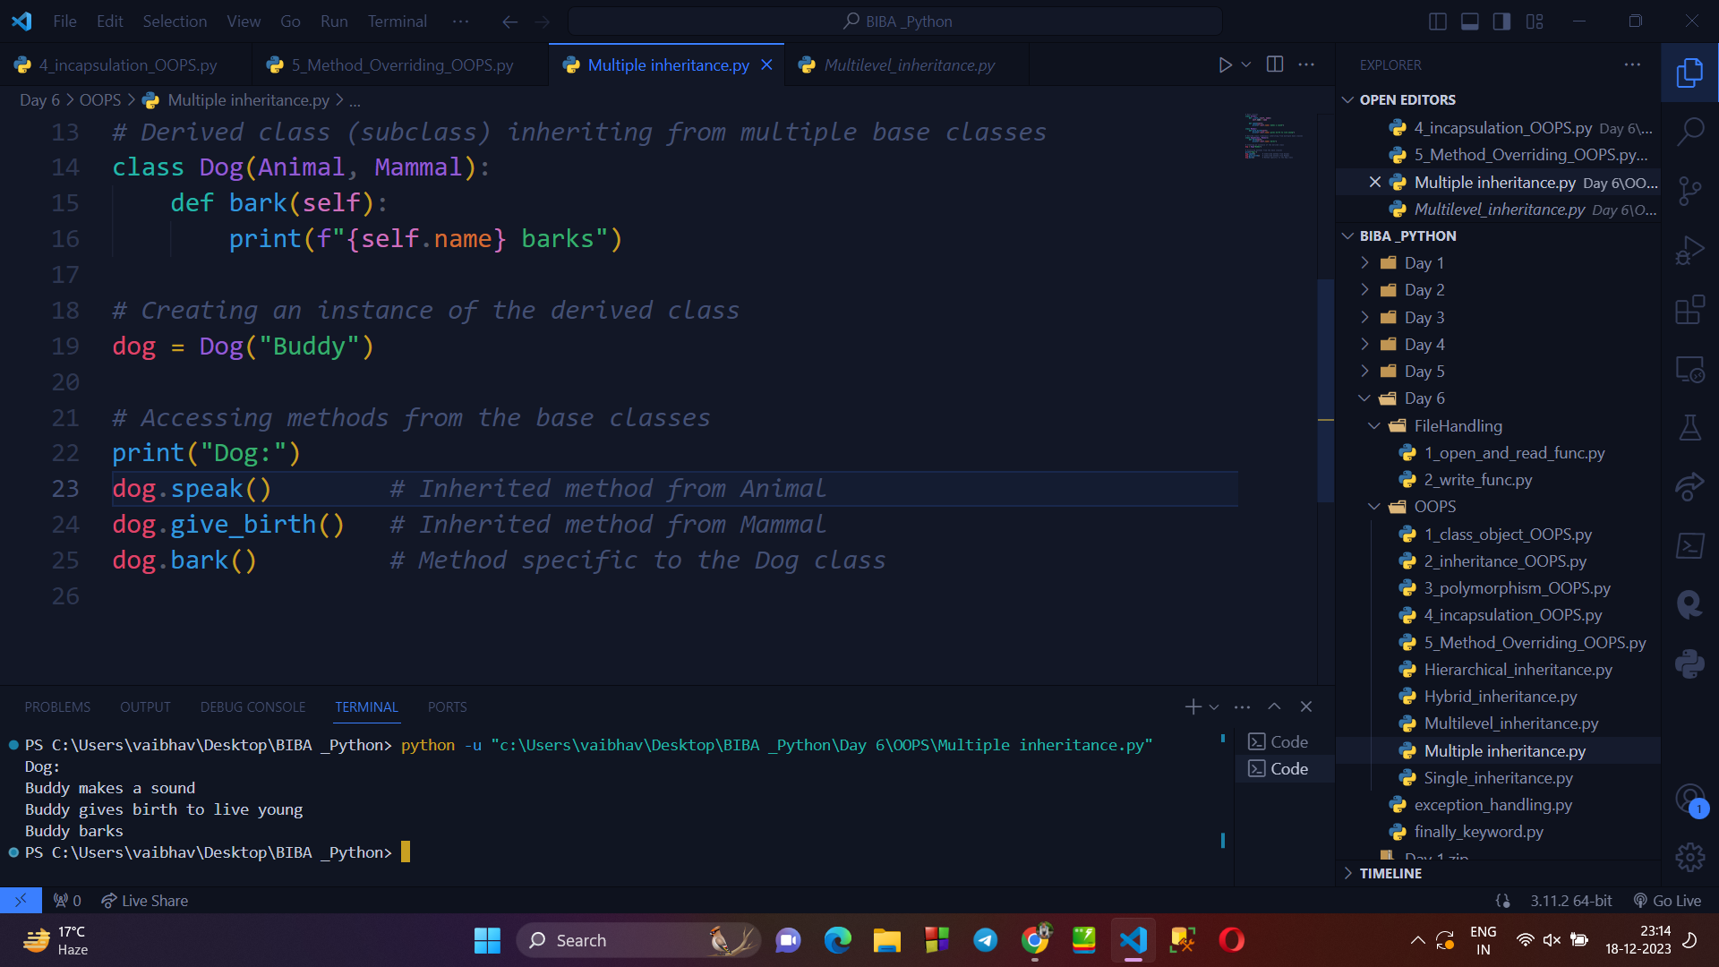

→ **FILE HANDLING IN PYTHON :**

* Python allows user to read and write in files.
* Each line of a file is terminated with a special character, called the EOL or End of Line characters like comma {,} or newline character.

**Writing a program to explain OPEN() & READ() Function :**

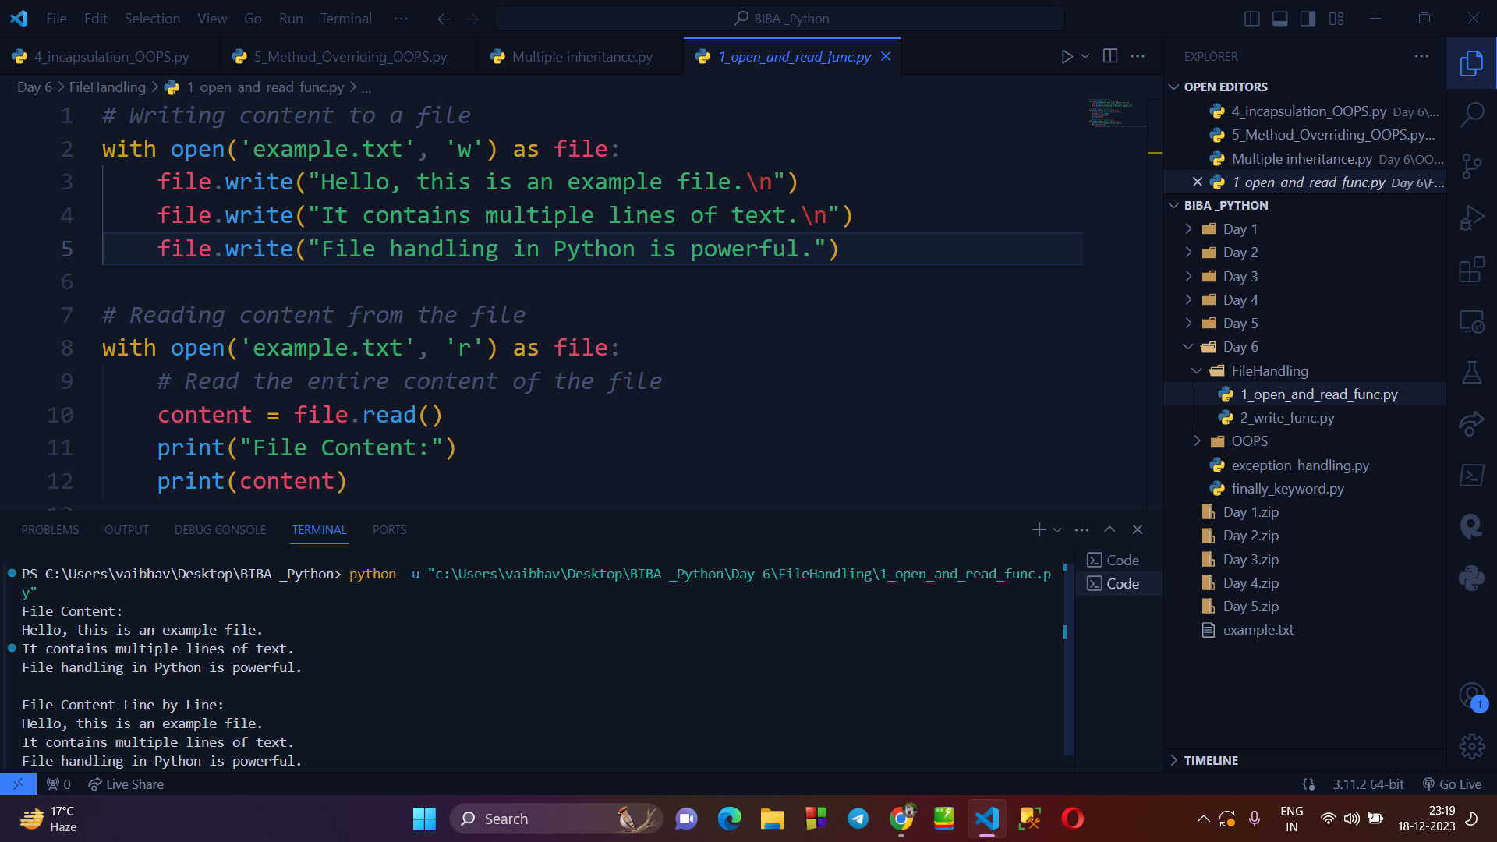

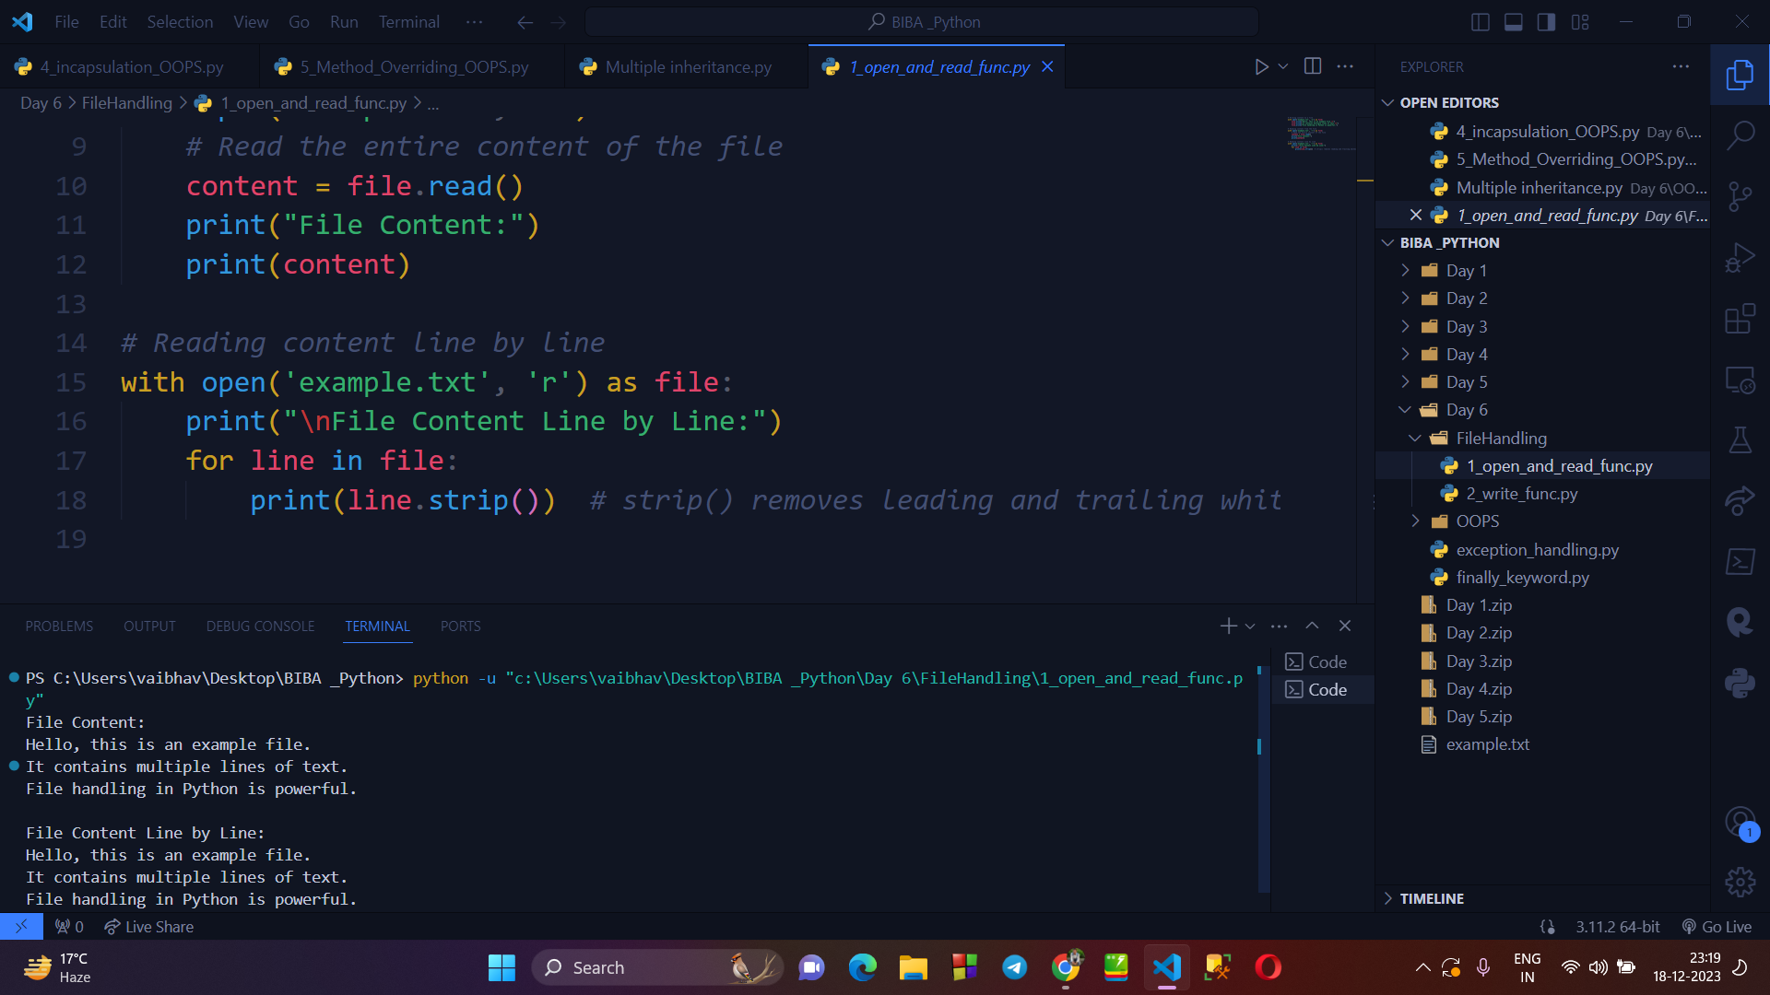

**Writing program to explain WRITE() function :**

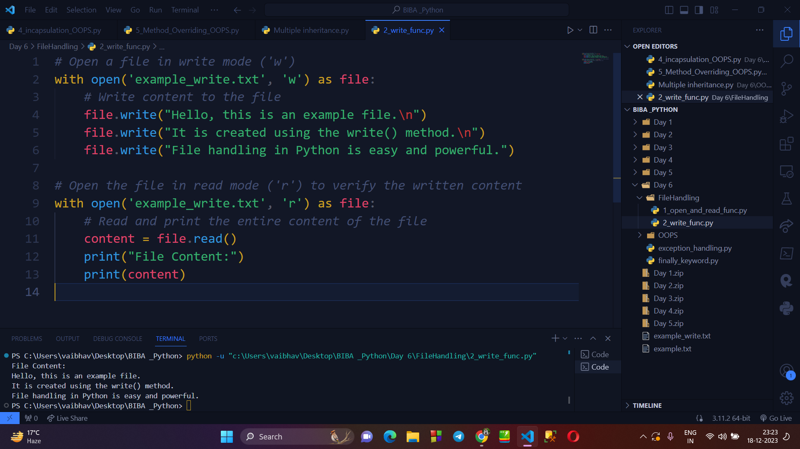

**→ EXCEPTION HANDLING IN PYTHON :**

1. In python there are several exceptions which can be raised during the execution of program. These are as follows :
   1. Syntax Error
   2. Type Error
   3. Name Error
   4. Index Error
   5. Key Error
   6. Value Error
   7. Attribute Error
   8. IO Error
   9. Zero Division Error
   10. Import Error

**Writing a program to explain EXCEPTION HANDLING :**

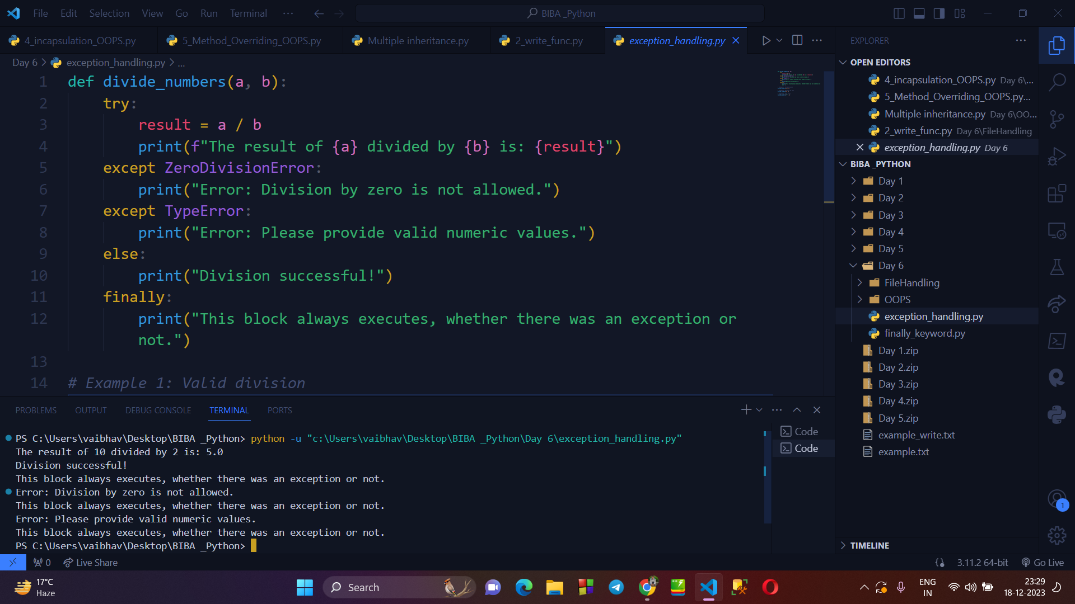

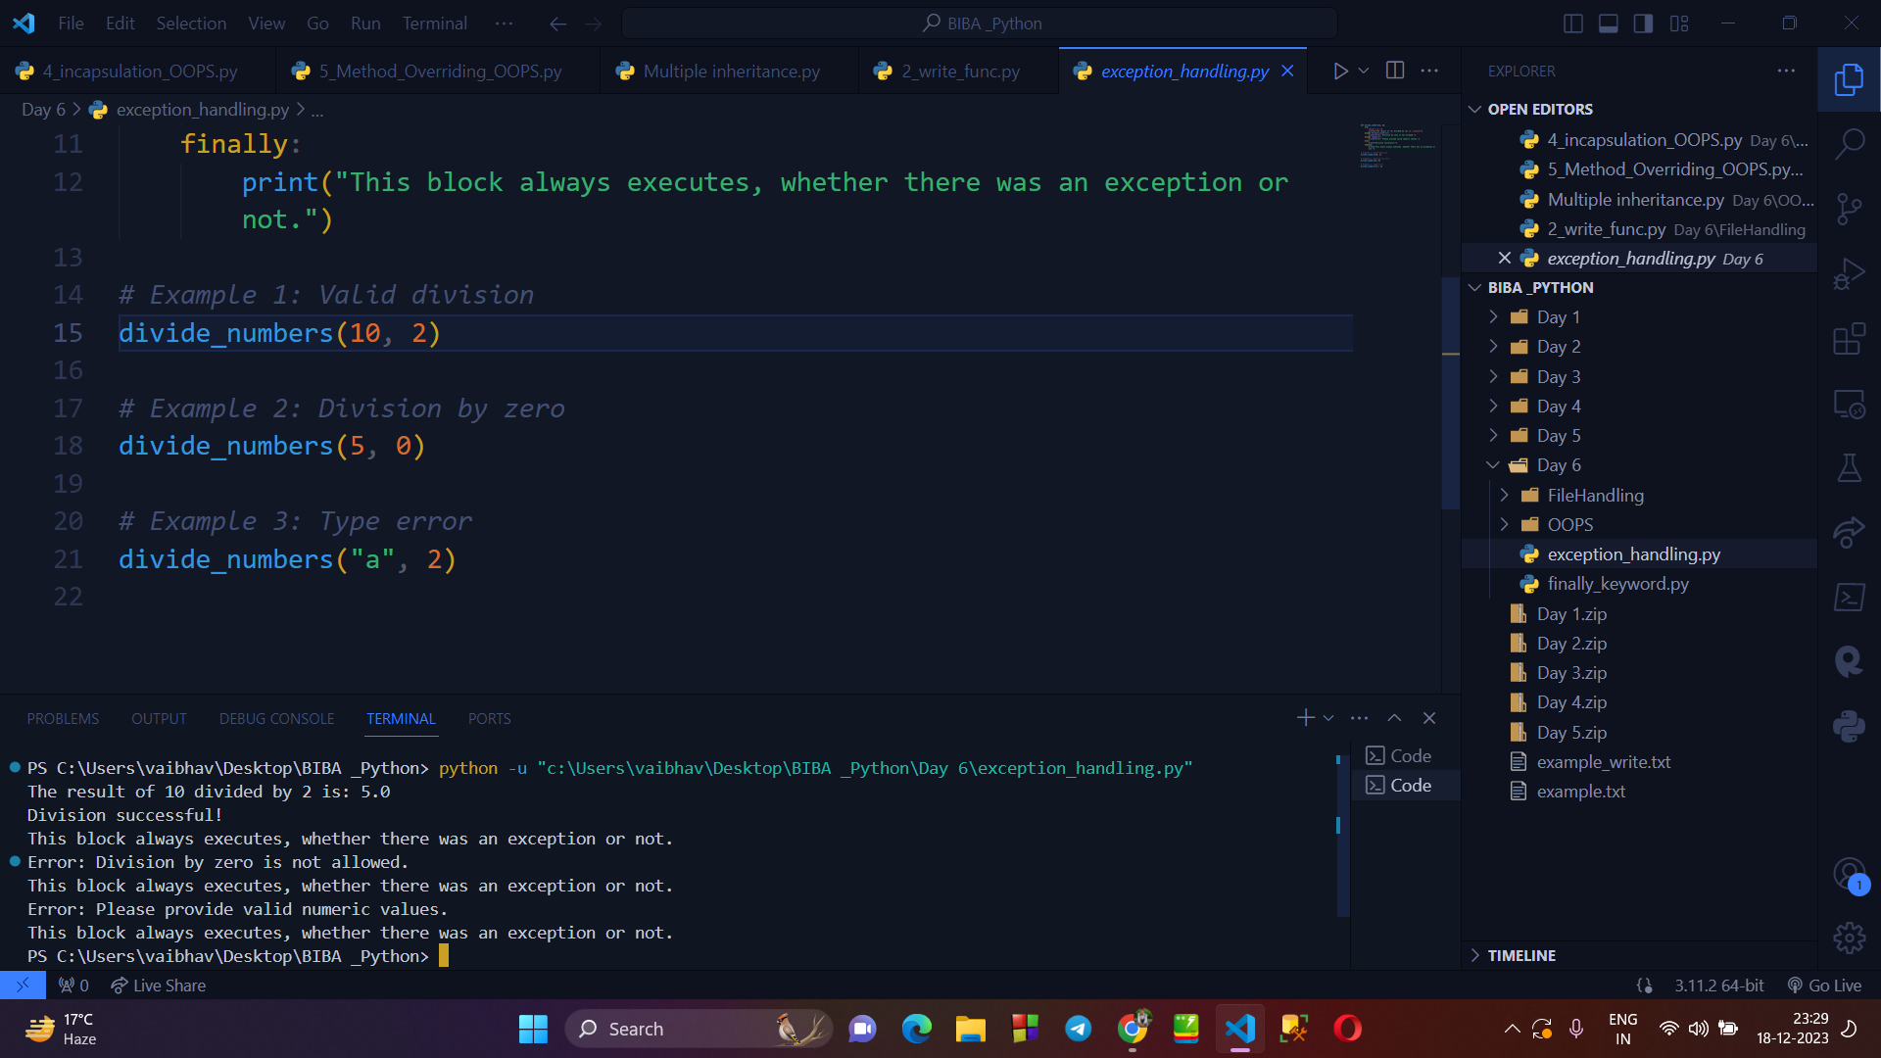

**→ FINALLY KEYWORD :**

* Python provides a finally keyword, which always executes after the execution of try and except blocks.

**Writing a program using FINALLY KEYWORD :**

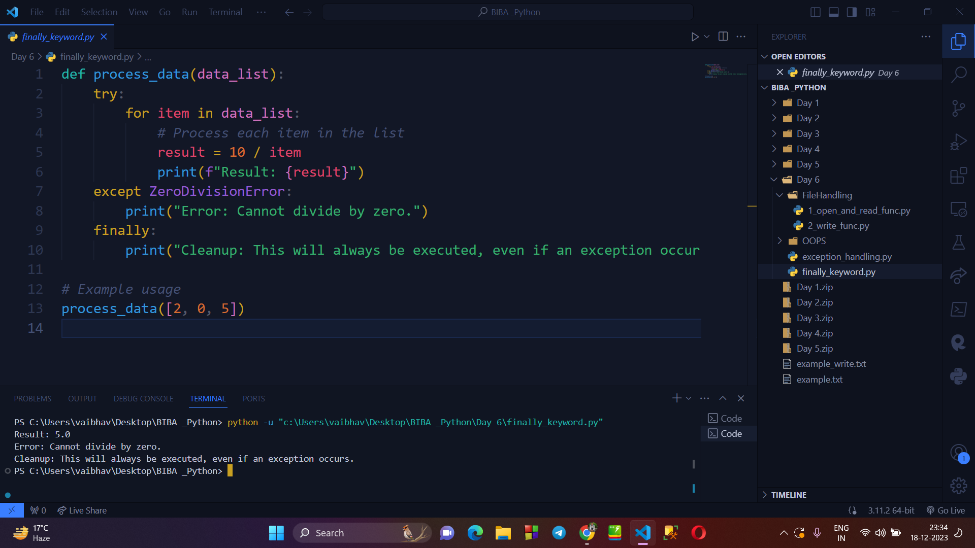

**→ MODULE HANDLING :**

* In python we have multiple built-in modules, which we can import and use where required in our code.
* But, we can create our own module also, and can iport and use it as usual.

**CREATING OUR OWN MODULE “my_module.py” :**

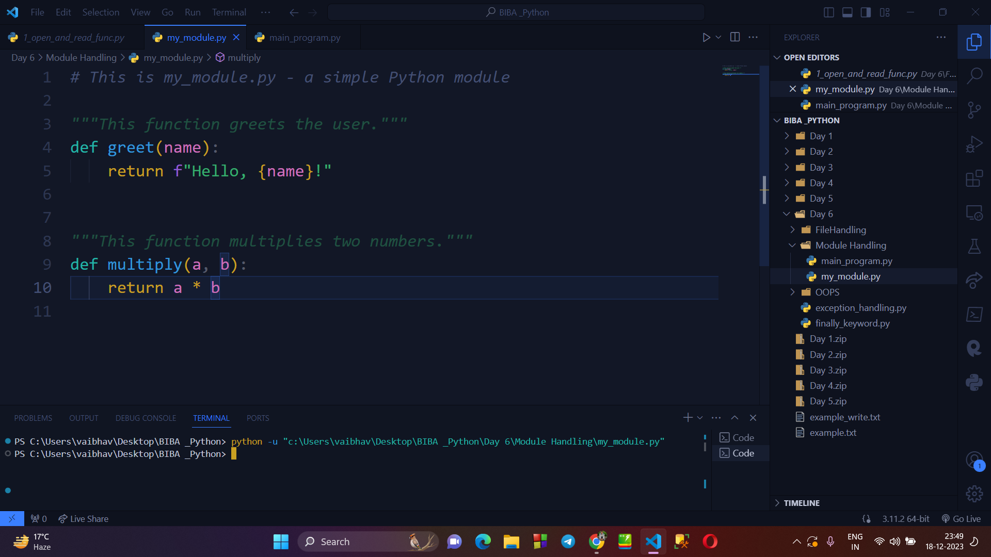

**IMPORTING OUR MODULE IN OTHER FILE AND USE IT :**

